Sphero Research Project
Setting Up Visual Studio Code & Sphero Code

First Time Setup:

- Download and Install Microsoft Visual Studio Code (VS Code):
(Mac/Windows): https://code.visualstudio.com/download

- Open VS Code 🡪 File 🡪 Open Folder

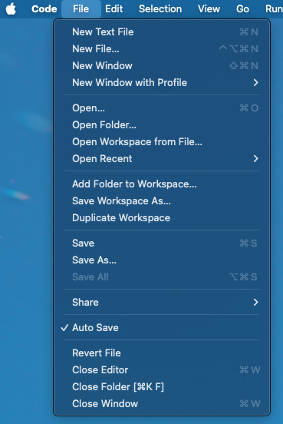

- Create a New Folder:
- Make a new folder called “Sphero-Research-Project” wherever you would like to save the project files.

- Click Open: to use this empty folder as your project directory.
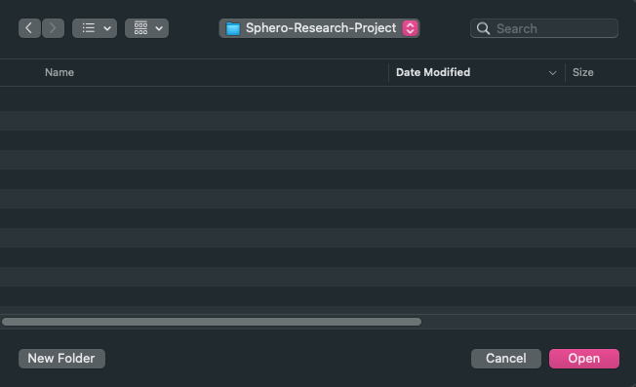

- Click Terminal 🡪 New Terminal
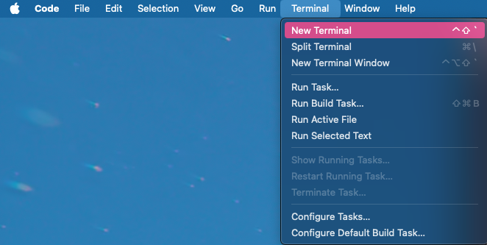

- Clone the Git Repository: get a local copy of all necessary files at this link: https://github.com/Nanxi-Flaneuse/HRI
- METHOD 1:
- Clone the git repo by clicking on the “code” button and copying the link shown in the screenshot below
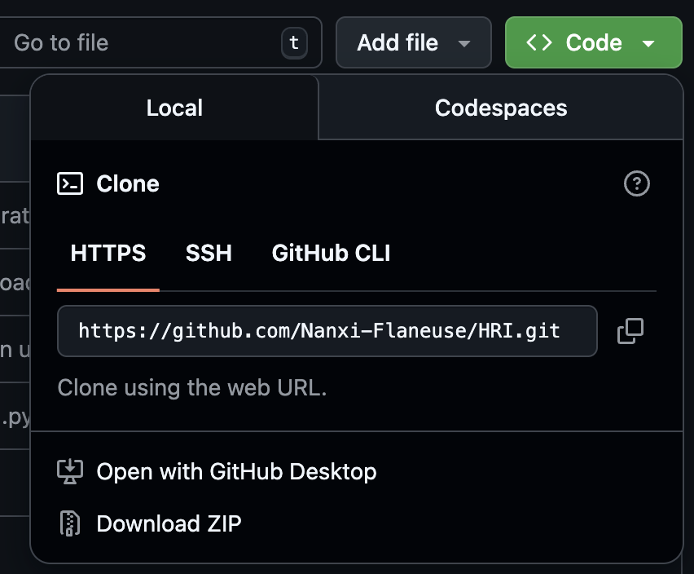
- Copy and paste this into your new terminal:
  - git clone [THE LINK YOU COPIED]
- METHOD 2:
  - Download github desktop
  - Select “Open with GitHub Desktop” after clicking on Code
Running your Sphero
- Open VS Code 🡪 File 🡪 Open Folder 🡪 Sphero-Research-Project
- Open the folder where you’ve saved all the project files

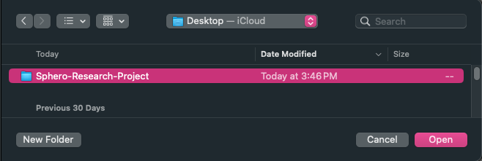
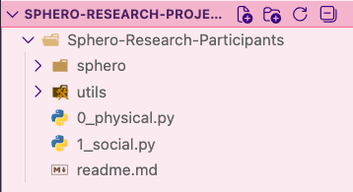

- Click Terminal 🡪 New Terminal

- Install your virtual environment: Move into the Sphero-Research-Participants directory and execute the following commands one by one in your terminal:
  - cd Sphero-Research-Participants (if you are not already in the Sphero-Research-Participants directory)
  - Python -m venv sphero
  - source sphero/bin/activate
  - pip install -r requirements.txt (or if this doesn’t work, try pip3 install -r requirements.txt)

- Make one change to the spherov2 library following instructions in the screenshot below:
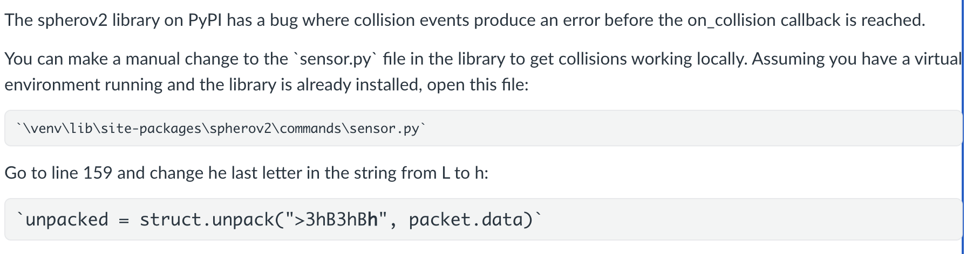
- Running Physical / Social: Sphero Research Conditions
5a. If you are currently in the “Physical” arm, click the file “0_physical.py”
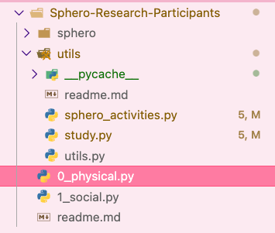
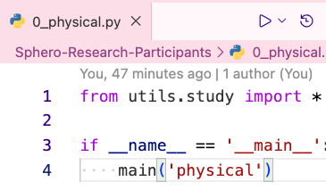
- Then click the “run” button on the top right.

5b. If you are currently in the “Social” arm, click the file “1_social.py”
- Then click the “run” button on the top right.
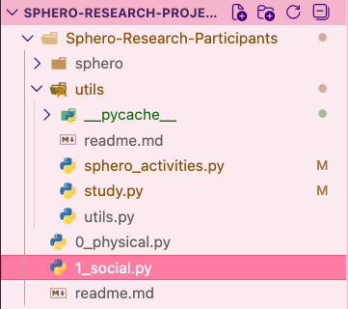
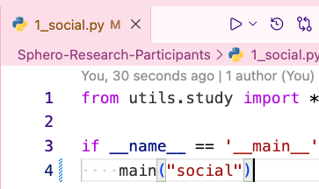

- That’s it! Just leave your Sphero buddy nearby while you work, and leave VS Code open and running in the background.
- Use our website to track the start and end of your study session, and log when you complete a stretch.
- Everyday when you try to rerun the code, you’ll need to activate your virtual environment first then execute the file.
  - Paste this command into your terminal to activate virtual environment:
  - source sphero/bin/activate
More instructions on the next page →
Disconnect & End
- When you are done with your studying/working session:
- Disconnect your Sphero and quit the program by clicking the “Stop” button in VS Code.
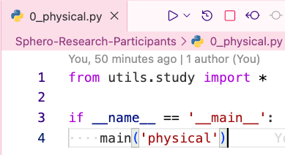

- Navigate to our website, and click “End Study Session”.
- If you forget to log any events (start/end time, or a stretch break), you may manually enter this information on the “Manual Entry” tab.

Thank you for participating in our study!!

